ENGINEERING SPECIFICATION

PULTRUDED FIBERGLASS BAFFLE PANELS

SECTION 06610

FIBERGLASS REINFORCED PLASTICS (FRP) FABRICATIONS

PULTRUDED FIBERGLASS BAFFLE PANELS

PART 1 - GENERAL

1.1 SCOPE OF WORK

The CONTRACTOR shall furnish, fabricate (where necessary), and install all fiberglass reinforced plastic (FRP) items, with all appurtenances, accessories and incidentals necessary to produce a complete, operable and serviceable installation as shown on the Contract Drawings and as specified herein, and in accordance with the requirements of the Contract Documents.

1.2 REFERENCES

The publications listed below (latest revision applicable) form a part of this specification to the extent referenced herein. The publications are referred to within the text by the designation only.

AMERICAN SOCIETY FOR TESTING AND MATERIALS (ASTM) Test
Methods:

ASTM D-638-Tensile Properties of Plastics

ASTM D-790-Flexural Properties of Unreinforced and Reinforced Plastics

ASTM D-2344-Apparent Interlaminar Shear Strength of Parallel Fiber Composites by Short Beam Method

ASTM D-696-Coefficient of Linear Thermal Expansion for Plastics

ASTM E-84-Surface Burning Characteristics of Building Materials

NSF/ANSI STANDARD 61

1.3 CONTRACTOR SUBMITTALS

- The CONTRACTOR shall furnish shop drawings of all fabricated baffle systems and accessories in accordance with the provisions of this Section.

- The CONTRACTOR shall furnish manufacturer's shop drawings clearly showing material sizes, types, styles, part or catalog numbers, complete details for the fabrication of and erection of components including, but not limited to, location, lengths, type and sizes of fasteners, clip angles, member sizes, and connection details.

- The CONTRACTOR shall submit the manufacturer’s published literature including structural design data, structural properties data, corrosion resistance tables, certificates of compliance, test reports as applicable, and design calculations for systems not sized or designed in the contract documents, sealed by a Professional Engineer.

- The CONTRACTOR may be requested to submit sample pieces of each item specified herein for acceptance by the ENGINEER as to quality and color. Sample pieces shall be manufactured by the method to be used in the WORK.

1.4 QUALITY ASSURANCE

- Manufacturer Qualifications: Firm experienced in successfully producing FRP fabrications similar to that indicated for this project, with sufficient production capacity to produce required units without causing delay in the work.

- Manufacturer shall offer a 3 year limited warranty on all FRP products against defects in materials and workmanship.

1.5 PRODUCT DELIVERY AND STORAGE

- Delivery of Materials: Manufactured materials shall be delivered in original, unbroken pallets, packages, containers, or bundles bearing the label of the manufacturer. Adhesives, resins and their catalysts and hardeners shall be crated or boxed separately and noted as such to facilitate their movement to a dry indoor storage facility.

- Storage of Products: All materials shall be carefully handled to prevent them from abrasion, cracking, chipping, twisting, and other types of damage. Store adhesives, resins and their catalysts and hardeners in dry indoor storage facilities between 70 and 85 degrees Fahrenheit (21 to 29 degrees Celsius) until they are required.

PART 2 - MATERIALS

2.1 MANUFACTURER

A. Baffle Panels shall be manufactured by

Bedford Reinforced Plastics, Inc.
One Corporate Drive, Suite 106
Bedford, PA 15522. USA
(814) 623-8125 Phone
(814) 623-6032 Fax
Website: https://bedfordreinforced.com

2.2 GENERAL

- Baffle Panels are to be manufactured by the pultrusion process with a glass content minimum of 45%, maximum of 55% by weight. The baffle panels shall be composed of fiberglass reinforcement and resin in qualities, quantities, properties, arrangements and dimensions as necessary to meet the design requirements and dimensions as specified in the Contract Documents.

- Fiberglass reinforcement shall be a combination of continuous roving, continuous strand mat, and surfacing veil in sufficient quantities as needed by the application and/or physical properties required.

- Resins shall be {ISO, non-fire retardant isophthalic polyester used to produce NSF Standard 61 certified shapes; ISOFR, fire retardant isophthalic polyester; VE, non-fire retardant vinyl ester used to produce NSF Standard 61 certified shapes or VEFR, fire retardant vinyl ester, (choose one)} with chemical formulation necessary to provide the corrosion resistance, strength and other physical properties as required.

- All finished surfaces of FRP items and fabrications shall be smooth, resin-rich, free of voids and without dry spots, cracks, crazes or unreinforced areas. All glass fibers shall be well covered with resin to protect against their exposure due to wear or weathering.

- Baffle Panels shall be further protected from ultraviolet (UV) attack with 1) integral UV inhibitors in the resin and 2) a synthetic surfacing veil to produce a resin rich surface.

- All fire retardant FRP products shall have a tested flame spread rating of 25 or less per ASTM E-84 Tunnel Test.

- Baffle Panels are to have the minimum longitudinal mechanical properties listed below:

Property | ASTM Method | Value | Units
Tensile Strength | D-638 | 30,000 (206) | psi (MPa)
Tensile Modulus | D-638 | 2.5 x 10⁶ (17.2) | psi (GPa)
Flexural Strength | D-790 | 30,000 (206) | psi (MPa)
Flexural Modulus | D-790 | 1.8 x 10⁶ (12.4) | psi (GPa)
Flexural Modulus (Full Section) | N/A | 2.8 x 10⁶ (19.3) | psi (GPa)
Short Beam Shear (Transverse) | D-2344 | 4,500 (31) | psi (MPa)
Shear Modulus (Transverse) | N/A | 4.5 x 10⁵ (3.1) | psi (GPa)
Coefficient of Thermal Expansion | D-696 | 7.0 x 10⁻⁶  (12.6 x 10 ⁻⁶) | in/in/°F  (cm/cm/°C)
Flame Spread | E-84 | 25 or less | N/A

2.3 DESIGN CRITERIA

- The design of the baffle system including connections shall be in accordance with governing building codes and standards as applicable.

- Design load shall be the greater of water differential or wind load in drained condition, but no combination of the two.

2.4 BAFFLE PANEL PROPERTIES

- Baffle Panels should be 24” wide (nominal) and have the following section properties per full width of panel:
A = 9.584 in^2
I = 9.85 in^4
s = 6.97 in^3
Modulus of Elasticity = 4.2 x 10^6 psi
Weight = 7.89 lbs/ft

- Baffle Panels shall have a depth of 2.75” and a nominal thickness of ¼”. The horizontal ribs of the panel shall be sloped downward to minimize sediment build-up.

- Baffle Panel performance shall be as stated in the following table:

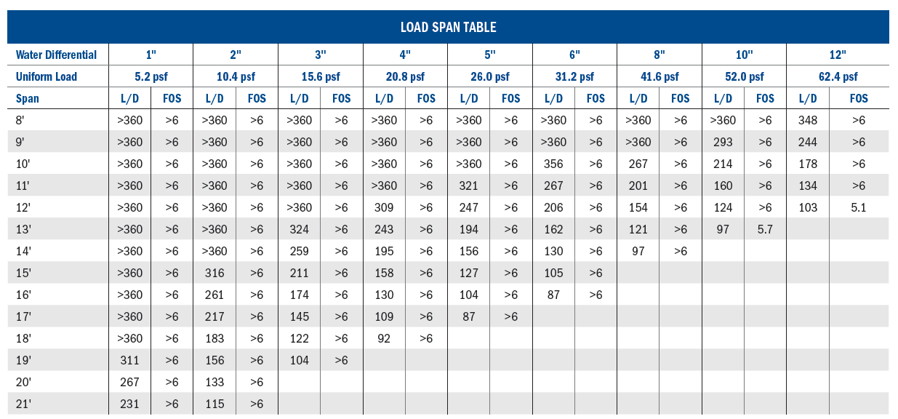

PART 3 - EXECUTION

3.1 FABRICATION

- Measurements: Baffle Panels supplied shall meet the minimum overall dimensional requirements as shown or specified. The Contractor shall provide and/or verify measurements in field for work fabricated to fit field conditions as required by manufacturer to complete the work. Determine correct size and locations of required holes or coping from field dimensions before fabrication.

- Hardware: Type 316 stainless steel bolts shall be provided.

3.2 INSPECTION

- Shop inspection is authorized as required by the Owner and shall be at Owner's expense. The fabricator shall give ample notice to Contractor prior to the beginning of any fabrication work so that inspection may be provided. The baffle panels shall be as free, as commercially possible, from visual defects such as foreign inclusions, delamination, blisters, resin burns, air bubbles and pits.

3.3 INSTALLATION

- Contractor shall be required to install the baffle panels in strict accordance with manufacturer’s instructions.

- Follow manufacturer's instructions when cutting or drilling fiberglass products. Provide adequate ventilation.

END OF SECTION

